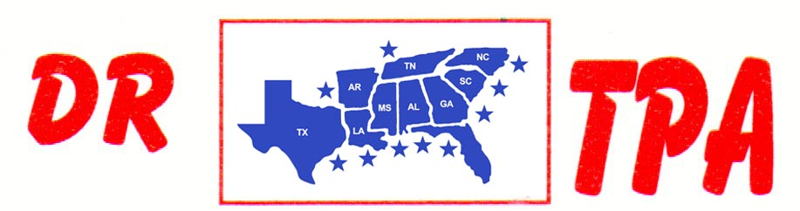

SA PRODUCTIONS, LLC
UNADILLA, GA
FEBRUARY 24-26, 2023
SHOW RESULTS - #202305

#11 MIXED PEN - $2445 ($500 ADDED MONEY)
1st PLACE CLINT PRICE – AUBREE COKER – GINNY EHENCLOU
2ND PLACE MOLLY EHRENCLOU – DALE TENNANT – GINNY EHRENCLOU
3RD PLACE AUBREE COKER – COLLEEN GALLOWAY – TRENT KNIGHT
4TH PLACE HALEY KNIGHT – SCOTT KNIGHT – COLLEEN GALLOWAY

#9 PEN/#5 INCENTIVE - $1557 ($500 ADDED MONEY)
1ST PLACE TRENT KNIGHT – AUBREE COKER – STEVE WELCH
2ND PLACE TRENT KNIGHT – MOLLY EHRENCLOU – AUBREE COKER
3RD PLACE GINNY EHRENCLOU – MOLLY EHRENCLOU – DALE TENNANT

#5 INCENTIVE - $396
1ST PLACE CAIDEN KRAKER – MIA KIRKSEY – ABIGAIL KNIGHT

#8 SORT – $1776 ($750 ADDED MONEY)
1st PLACE CRYSTAL PARKER – SCOTT KNIGHT
2nd PLACE CRYSTAL PARKER – BETH LINDER

#7 MIXED SORT – $2414
1st PLACE CASEY ROBINSON – CRYSTAL PARKER
2nd PLACE HALEY KNIGHT – LARRY JORDAN
3RD PLACE GRACIE FORTNER – RANDY MOORE
4TH PLACE RANDY MOORE – KIM HIERS
5TH PLACE CRYSTAL PARKER – LARRY JORDAN

#6 SHOOTOUT SORT – $5370 ($1000 ADDED MONEY)
1ST PLACE BETH LINDLER – HALEY KNIGHT
2ND PLACE ROBERT BARBER – AUBREE COKER
3RD PLCE GINNY EHRENCLOU – MOLLY EHRENCLOU
4TH PLACE HALEY KNIGHT – TRENT KNIGHT
5TH PLACE CRYSTAL PARKER – HALEY KNIGHT

#5 SORT/#3 INCENTIVE – $2106
1ST PLACE TRENT KNIGHT – KIM HIERS
2ND PLACE TRENT KNIGHT – ABIGAIL KNIGHT
3RD PLCE JIMMY SPEARS – KIM HIERS
4TH PLACE MARCIA COKER – SCOTT KNIGHT
5TH PLACE TANNER HUFF – RANDY MOORE
6TH PLACE GAGE MOORE – TRENT KNIGHT

#3 INCENTIVE – $1560
1ST PLACE JIMMY SPEARS – KIM HIERS
2ND PLACE TANNER HUFF – RANDY MOORE
3RD PLCE JADE AMMONS – JERRY SALTER
4TH PLACE MARCI SPEARS – AJ PARKER
5TH PLACE ABIGAIL KNIGHT – STACY KNIGHT

YOUTH SORT – $778 ($250 ADDED MONEY)
1ST PLACE GINNY EHRENCLOU – AUBREE COKER
2ND PLACE GINNY EHRENCLOU – GAGE MOORE
3RD PLACE ALLIE AMMONS – CARLY ROBINSON

8 COW DRAW 3 & ABOVE - $2236 8 COW DRAW 1-2 RATED RIDERS - $3104
1ST PLACE HALEY KNIGHT 1ST PLACE LARUEN WHITE
2ND PLACE JERRY SALTER 2ND PLACE CHANTALE PARENT
3RD PLACE KIM HEIRS 3RD PLACE JERRY SALTER
4TH PLACE SCOTT KNIGHT 4TH PLACE ROBERT BARBER
5TH PLACE CRYSTAL PARKER 5TH PLACE RYAN AMMONS

