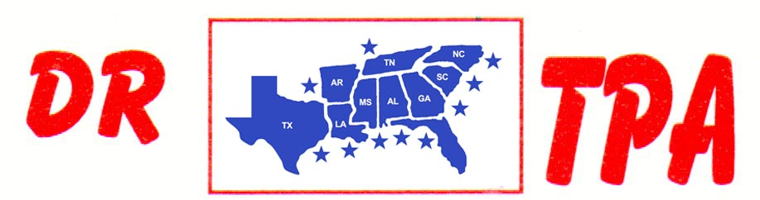

BUCKNER COW HORSES
BASTROP, TX
FEBRUARY 25-26, 2023
SHOW RESULTS - #202304

OPEN HC PENNING - $1104
1st PLACE MICHAEL BAZE – SHERI MURRAY – DEANNE SAMPSON
2ND PLACE SHIANN BUCKNER – SHERI MURRAY – MICHAEL BAZE

#11 MIXED PENNING - $1152
1st PLACE JOHN CECIL – DEANNE SAMPSON – TRAVIS ROBERSON
2ND PLACE SONYA BUCKNER – MARCO GARCIA – MIKE ROBINSON

#9 PENNING - $864
1st PLACE MIKE ROBINSON – TRAVIS ROBERSON – DEANNE SAMPSON
2ND PLACE MIKE ROBINSON – SHIANN BUCKNER – SHERI MURRAY

ALL DRAW RANCH SORTING - $1600
1ST PLACE TOMMY ROBERSON – DAVID TELTOW
2ND PLACE TOMMY ROBERSON – DEANNE SAMPSON
3RD PLACE KAREN MCCRAY – PAMELA GARRETT
4TH PLACE TRAVIS ROBERSON – JOHN CECIL

#8 RANCH SORTING - $1632
1ST PLACE DAN SPRADLEY – TOMMY ROBERSON
2ND PLACE DANIE TELTOW – SHERI MURRAY
3RD PLACE SAVANNAH MALONE – JENNA O’NEIL
4TH PLACE TOMMY ROBERSON – MIKE ROBINSON
5TH PLACE BECKIE SHEPPARD – DARLENE OLSEN

#5 RANCH SORTING - $1696
1ST PLACE LAURA SELLERS – TRACEY O’NEIL
2ND PLACE JOHN CECIL – KIM BAKER
3RD PLACE SANDY SCHAFFNER – SHIANN BUCKNER
4TH PLACE JOE VELA – ED LOREN
5TH PLACE RENEE LEACH – SAVANNAH MALONE

