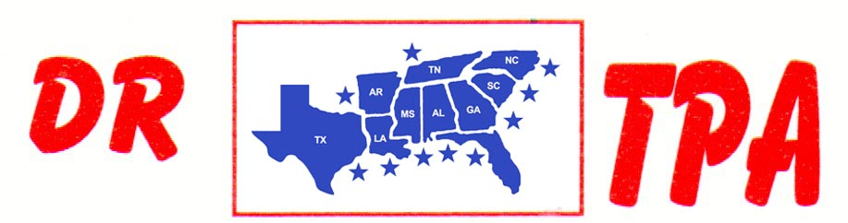

BUCKNER COW HORSES
BASTROP, TX
MARCH 18-19, 2023
SHOW RESULTS - #202306

OPEN HC PENNING - $1104
1st PLACE SONYA BUCKNER – RANDY SHEPPARD WAYNE VINSON
2ND PLACE SHIANN BUCKNER – SONYA BUCKNER – DAVID TELTOW

#11 MIXED PENNING - $1488
1st PLACE WAYNE VINSON – DEANNE SAMPSON – TRAVIS ROBERSON
2ND PLACE VAL TAMME – RANDY SHEPPARD – JOHN CECIL
3RD PLACE DANIE TELTOW – TRAVIS ROBERSON – SHIANN BUCKNER

#9 PENNING - $1008
1st PLACE SONYA BUCKNER – HEATHER NICKERSON – MICHAEL BAZE
2ND PLACE JOHN CECIL – STEVE CAWTHON – SHERI MURRAY

ALL DRAW RANCH SORTING - $1856
1ST PLACE KORI HAILE – SONYA BUCKNER
2ND PLACE CLAY VAUGHN – VAL TAMME
3RD PLACE WAYNE VINSON – SONYA BUCKNER
4TH PLACE TOMMY ROBERSON – MICHAEL BAZE
5TH PLACE MIKE ROBINSON – HUNTER BRZYMIALKIEWICZ

#8 RANCH SORTING - $1408
1ST PLACE KORI HAILE – SONYA BUCKNER
2ND PLACE SHELBY CAWTHON – SONYA BUCKNER
3RD PLACE KORI HAILE – SCOTT HENDERSON
4TH PLACE SHELBY CAWTHON – WAYNE VINSON

#5 RANCH SORTING - $1344
1ST PLACE MIKE ROBINSON – DAVID TELTOW
2ND PLACE MIKE ROBINSON – SHERI MURRAY
3RD PLACE AMI ALTOM – HUNTER BRZYMIALKIEWICZ
4TH PLACE MICHAEL BAZE – RANDY STEWART

