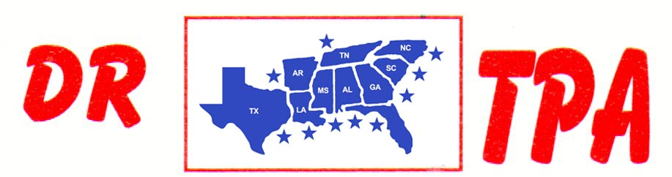

SA PRODUCTIONS, LLC
STATESBORO, GA
MARCH 28-29, 2025
SHOW RESULTS - #202512

#10 SHOOTOUT PEN - $4173 ($1000 ADDED MONEY)
1st PLACE TRENT KNIGHT – PAUL BLEVINS – NATALIE BARKER
2ND PLACE KASEY COLEMAN – TRENT KNIGHT – SCOTT KNIGHT
3RD PLACE CRYSTAL PARKER – TRENT KNIGHT – KASEY COLEMAN
4TH PLACE CHET BARRETT – TRENT KNIGHT – AUBREE COKER

#7 PEN - $1812 ($500 ADDED MONEY)
1ST PLACE MARCI SPEARS – MATT KEEL – HOLLY LANPHER
2ND PLACE HOLLY LANPHER – PAUL BLEVINS – CHET BARRETT

OPEN HC SORT - $1512 ($500 ADDED MONEY)
1ST PLACE RANDY MOORE – TRENT KNIGHT
2ND PLACE SCOTT KNIGHT – RANDY MOORE

#8 SORT – $2714 ($500 ADDED MONEY)
1st PLACE RANDY MOORE – TRENT KNIGHT
2nd PLACE SCOTT KNIGHT – AUBREE COKER
3RD PLACE AUBREE COKER – WILL FORTNER
4TH PLACE TRENT KNIGHT – JERRY SALTER
5TH PLACE KAI CLARK – WILL FORTNER

#6 SHOOTOUT SORT – $5364 ($1500 ADDED MONEY)
1st PLACE AUBREE COKER – ABIGAIL KNIGHT
2nd PLACE JERRY SALTER – SCOTT KNIGHT
3RD PLACE AUBREE COKER – CHET BARRETT
4TH PLACE HOLLY LANPHER – AUBREE COKER
5TH PLACE CHET BARRETT – SCOTT KNIGHT

#5 SORT – $5006 ($500 ADDED MONEY)
1st PLACE MIKE DILLON – KASEY COLEMAN
2nd PLACE DANNY KIMBALL – MAKENNA EMMONS
3RD PLACE JOSIE REED – JEREMY REED
4TH PLACE HANNAH BAILEY – SYDNEY STARNES
5TH PLACE MATT KEEL – EVIE JANE HOOPER

#3 SORT – $2478 ($500 ADDED MONEY)
1ST PLACE CHET BARRETT – BO HOOPER
2ND PLACE RANDY MOORE – BAILEY LANHAM
3RD PLCE CAIDEN KRAKER – RANDY MOORE
4TH PLACE KEN BEASLEY – JUSTIN STARNES
5TH PLACE SAYDEE COKER – RANDY MOORE

YOUTH SORT – $650 ($250 ADDED MONEY)
1ST PLACE ANNIE EHRENCLOU – ABIGAIL KNIGHT
2ND PLACE ABIGAIL KNIGHT – CAIDEN KRAKER

