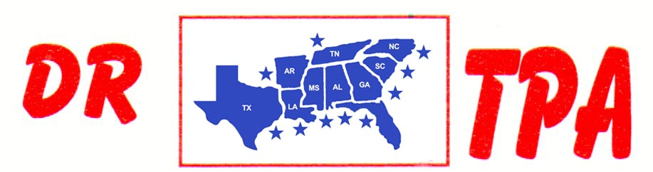

E4 FARMS
BROOKHAVEN, MS
MARCH 29, 2025

SHOW RESULTS - #202513

OPEN HC TEAM PENNING – $540
1st PLACE CLAY EARLS – PATRICK HALL – BROOKE MITCHELL

8 COW DRAW GROUP A - $630
1ST PLACE CHAD MITCHELL
2ND PLACE KADEN DEASON
3RD PLACE TODD SIBLEY

8 COW DRAW GROUP B - $630
1ST PLACE BROOKE MITCHELL
2ND PLACE WALTER TEDESCO
3RD PLACE CHAD CAMPBELL

YOUTH SORT – $192
1st PLACE LAYTON EARLS – KATELYN WATKINS

