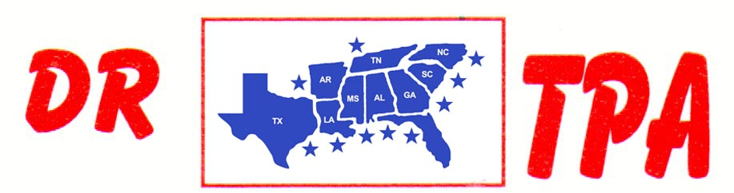

DJ COWHORSES
MCCOOL, MS
APRIL 1, 2023

SHOW RESULTS - #202310

8 COW DRAW - CLASS A – $1260
1st PLACE CHAD MITCHELL
2ND PLACE BAYLAS HAMILTON
3RD PLACE RICK DEAN

8 COW DRAW - CLASS B – $1260
1st PLACE LAVONNE STRINGER
2nd PLACE DUSTIN JOHNSON
3RD PLACE AJ PARKER

#6 RANCH SORT – $1470
1st PLACE MICHAEL EVANS – TANNER CHAPPELEAR
2ND PLACE MICHAEL EVANS – BAYLAS HAMILTON
3RD PLACE BAYLAS HAMILTON – CHAD MITCHELL
4TH PLACE LIZ KING – CRYSTAL PARKER

YOUTH RANCH SORT – $120
1st PLACE BRYSON DOAD – SOPHEE EVANS

