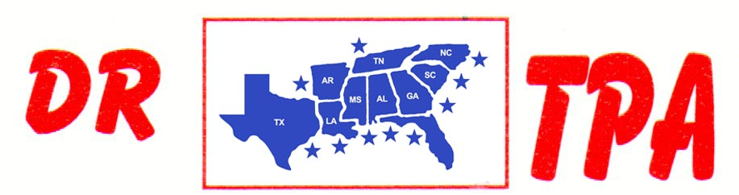

4K FARMS
YATESVILLE, GA
APRIL 01, 2023

SHOW RESULTS - #202313

8 COW DRAW - $2244
1ST PLACE HALEY KNIGHT 40 COWS
2ND PLACE JERRY SALTER 39 COWS
3RD PLACE TRENT KNIGHT 39 COWS
4TH PLACE SCOTT KNIGHT 37 COWS
5TH PLACE KAI CLARK 35 COWS

#6 RANCH SORT - $1353
1ST PLACE COURTNEY KELLY – SCOTT KNIGHT
2ND PLACE JERRY SALTER – TRENT KNIGHT
3RD PLACE FRED KRAMER – RENDER PIERCE
4TH PLACE TRENT KNIGHT – ABIGAIL KNIGHT

YOUTH SORT - $400
1ST PLACE ABIGAIL KNIGHT – IVY PIERCE
2ND PLACE AUBREE COKER – HARPER PIERCE

