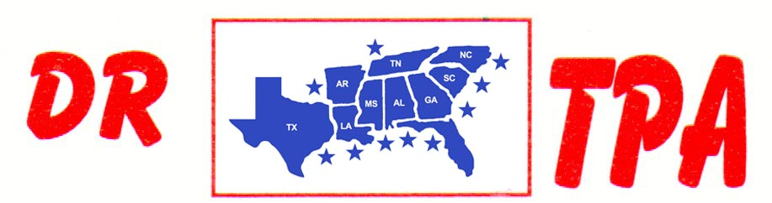

NO NAME ARENA
ALEXANDER, AR
APRIL 8, 2023

SHOW RESULTS - #202309

OPEN ALL DRAW RANCH SORTING - $2408
1ST PLACE COLLEEN GALLOWAY – DOUG VOLKMAN
2ND PLACE PAT HALL – COLEEN GALLOWAY
3RD PLACE DAVID CARNAHAN – SKIP DAVIDSON
4TH PLACE EDYE CROUSE – CHARLENE SULLIVAN
5TH PLACE DOUG VOLKMAN – PAT HALL

#8 RANCH SORTING - $2608
1ST PLACE DESTINY GILLIHAN – COLLEEN GALLOWAY
2ND PLACE CASH FOWLER – ELLIE FOWLER
3RD PLACE DOUG VOLKMAN – LAYNE PENFIELD
4TH PLACE DESTINY GILLIHAN – CHRISTY HALEY
5TH PLACE JASON HALEY – LAYNE PENFIELD

#13 3 MAN/2 GATE SORTING - $1239
1ST PLACE JASON HALEY – ROY SATTLER – SAMMY DUNCAN
2ND PLACE ROY SATTLER – LAYNE PENFIELD – DOUG VOLKMAN

