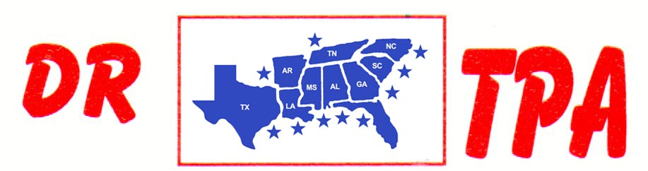

4K FARMS
YATESVILLE, GA
APRIL 11-12, 2025

SHOW RESULTS - #202516

8 COW DRAW - $3300
1ST PLACE IOSVANY CASTILLO 45 COWS
2ND PLACE STEVE WELCH 44 COWS
3RD PLACE AMY SODREL 39 COWS
4TH PLACE HALEY KNIGHT 31 COWS
5TH PLACE TRENT KNIGHT 29 COWS

#6 SHOOTOUT SORT - $3266
1ST PLACE OMAR DIAZ – DANNY SODREL
2ND PLACE KAIDEN KRAKER – RANDY MOORE
3RD PLACE CHET BARRETT – JERRY SALTER
4TH PLACE LARRY JORDAN – DANNY SODREL
5TH PLACE TONY RODRIGUEZ – LARRY JORDAN

#YOUTH SORT - $376
1ST PLACE ABIGAIL KNIGHT – HARPER GRACE PIERCE

