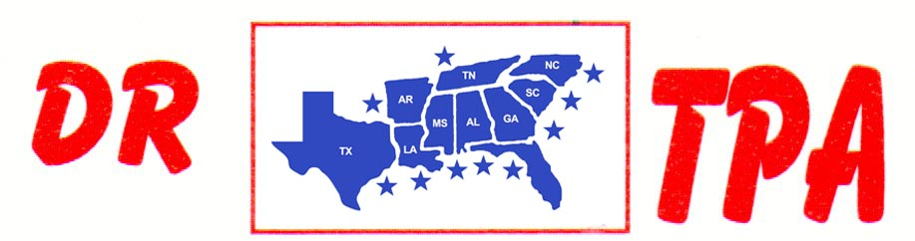

NO NAME ARENA
ALEXANDER, AR
MAY 3, 2025
SHOW RESULTS - #202519

OPEN ALL DRAW RANCH SORTING - $1120
1ST PLACE MARK ALLEN – BUCK MATTHEWS
2ND PLACE DAVID MCCOMAS – PAUL BULL
3RD PLACE LAYNE PENFIELD – BUCK MATTHEWS

#8 RANCH SORTING - $1890
1ST PLACE DAVID CARNAHAN – BUCK MATHEWS
2ND PLACE MICHELLE CARNAHAN – LAYNE PENFIELD
3RD PLACE JOE FORNEY – SKIP DAVIDSON
4TH PLACE JOE FORNEY – SETH WHITLEY
5TH PLACE BROCK SPURLOCK – JORDAN WHITLEY

#6 RANCH SORTING - $666
1ST PLACE JORDAN WHITLEY – JERRY WHITLEY
2ND PLACE JAMES SCHEIDER – SETH WHITLEY

