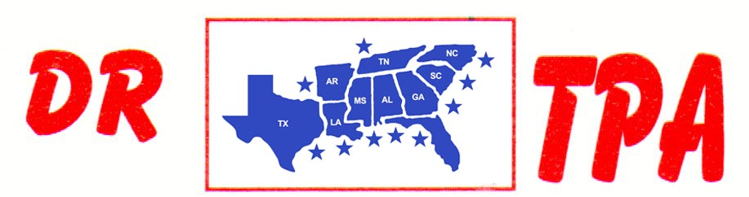

SA PRODUCTIONS, LLC
CLEMSON DERBY CLASSIC
May 5-7, 2023
SHOW RESULTS - #202316

OPEN HC PEN - $2370 ($500 ADDED MONEY)
1st PLACE LARRY JORDAN – DUSTIN JOHNSON – CODY ACORD
2ND PLACE COLLEEN GALLOWAY – KEVIN REESE – BAYLAS HAMILTON
3RD PLACE FRED KRAMER – JIMMY SPEARS – MARCUS KENT
4TH PLACE KEVIN REESE – DUSTIN JOHNSON – CODY ACORD

#11 MIXED PEN - $3186 ($500 ADDED MONEY)
1st PLACE COOPER BUZHARDT – CASEY ROBINSON – RAEGAN CODY
2ND PLACE COOPER BUZHARDT – TRENT KNIGHT – SCOTT KNIGHT
3RD PLACE JULIE MARTIN – DANNY SODREL – GREG BRIGHT
4TH PLACE RAEGAN CODY – KEVIN REESE – GREG BRIGHT
5TH PLACE BLAINE NOLAND – DAY WATSON – GREG BRIGHT

#9 PEN/#5 INCENTIVE - $2307 ($500 ADDED MONEY)
1ST PLACE AUBREE COKER – SCOTT KNIGHT – GAGE MOORE
2ND PLACE DANNY SODREL – KEVIN REESE – ELLA SNYDER
3RD PLACE RAEGAN CODY – CASEY ROBINSON – RYAN AMMONS
4TH PLACE KASEY COLEMAN – CARLY ROBINSON – CASEY ROBINSON
5TH PLACE ABIGAIL KNIGHT – SCOTT KNIGHT – TRENT KNIGHT

#5 INCENTIVE - $1152
1ST PLACE RANDY MOORE – FRED KRAMER – LARRY JORDAN
2ND PLACE LIZ KING – SHERRY KNIGHT – MARCIA COKER
3RD PLACE STEVE WELCH – COLTON BUZHARDT – CASEN BUZHARDT

#8 SORT – $4266 ($500 ADDED MONEY)
1st PLACE KEVIN REESE – IVEY KING
2nd PLACE MOLLY EHRENCLOU – TRENT KNIGHT
3RD PLACE GREG BRIGHT – CRYSTAL PARKER
4TH PLACE MOLLY EHRENCLOU – BETH LINDLER
5TH PLACE CASEY ROBINSON – SCOTT KNIGHT
6TH PLACE OLGA BARBELLA – JJ GONZALEZ

#5 SORT – $6068 ($500 ADDED MONEY)
1ST PLACE AUBREY COKER – HALEY KNIGHT
2ND PLACE CARLY ROBINSON – JIMMY SPEARS
3RD PLCE MARCI SPEARS – CRYSTAL PARKER
4TH PLACE JIM PHIPPS – LAUREN WHITE
5TH PLACE HALLIE BROWN – BELINDA MENDENHALL
6TH PLACE BLAIN NOLAND – GREG BRIGHT

#3 SORT – $3492
1ST PLACE CASH ROBINSON – RANDY MOORE
2ND PLACE CARLY ROBINSON – KASEY COLEMAN
3RD PLCE BELINDA SMITH – SALLY SHELL
4TH PLACE LARRY JORDAN – ALLIE AMMONS
5TH PLACE CARLY ROBINSON – MARCI SPEARS

YOUTH SORT – $932
1ST PLACE GAGE MOORE – ABIGAIL KNIGHT
2ND PLACE ALLIE AMMONS – CASH ROBINSON
3RD PLACE ANDIE REESE PORTH – CARLY ROBINSON
4TH PLACE CASH ROBINSON – ANDIE REESE PORTH

