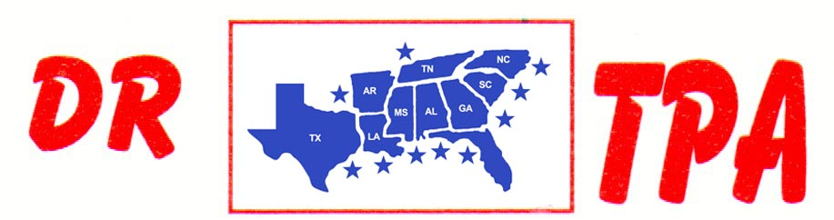

4K FARMS
YATESVILLE, GA
MAY 14, 2023

SHOW RESULTS - #202315

8 COW DRAW - $5544
1ST PLACE TRENT KNIGHT 50 COWS
2ND PLACE GRADY FORTNER 33 COWS
3RD PLACE MIKE DILLON 33 COWS
4TH PLACE SCOTT KNIGHT 32 COWS
5TH PLACE LILLIAN FORTNER 32 COWS
6TH PLACE KIM HILL 31 COWS
7TH PLACE HALEY KNIGHT 31 COWS

#6 RANCH SORT - $2772
1ST PLACE TRENT KNIGHT – KIM HILL
2ND PLACE SAGE RHODES – TRENT KNIGHT
3RD PLACE EVIE JANE HOOPER – GAGE MOORE
4TH PLACE MICHELLE FORTNER – SAYDEE COKER
5TH PLACE MIKE DILLON – HEIDI SAPP

YOUTH SORT - $800
1ST PLACE KAI CLARK = AUBREE COKER
2ND PLACE EVIE JAME HOOPER – KAI CLARK
3RD PLACE SAYDEE COKER – KAI CLARK

