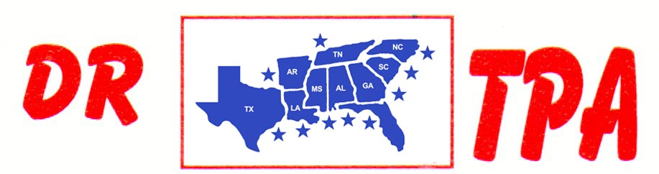

NO NAME ARENA
ALEXANDER, AR
APRIL 8, 2023

SHOW RESULTS - #202314

OPEN ALL DRAW RANCH SORTING - $1816
1ST PLACE COLLEEN GALLOWAY – LAYNE PENFIELD
2ND PLACE KENNETH ALTOM – SCOTT PHILLIPS
3RD PLACE DIANA DUNCAN – LAYNE PENFIELD
4TH PLACE DOUG VOLKMAN – SHERI MURRAY
5TH PLACE SCOTT PHILLIPS – AMI ALTOM

#8 RANCH SORTING - $1848
1ST PLACE LAYNE PENFIELD – COLLEEN GALLOWAY
2ND PLACE LAYNE PENFIELD – ROY SATTLER
3RD PLACE KENNETH ALTOM – BEN DAVIDSON
4TH PLACE JOE FORNEY – SKIP DAVIDSON
5TH PLACE ELLIE FOWLER – JASON HALEY

#13 3 MAN/2 GATE SORTING - $1680
1ST PLACE LAYNE PENFIELD – ROY SATTLER – DOUG VOLKMAN
2ND PLACE ROY SATTLER – CASH FOWLER – ELLIE FOWLER
3RD PLACE SKIP DAVIDSON – JASON HALEY – SCOTT PHILLIPS

