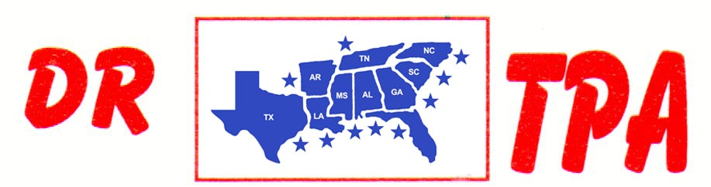

5K ARENA
BLADENBORO, NC
MAY 25, 2025
SHOW RESULTS - #202521

8 COW DRAW - $936
1st PLACE MIKE DILLON 46 COWS
2ND PLACE DALE TENNANT 46 COWS
3RD PLACE ADDY WYDOCK 46 COWS
4TH PLACE MEGAN TENNANT 38 COWS

#6 SORT - $832
1st PLACE JUSTIN JOHNSON – MIKE DILLON
2ND PLACE IVEY KING – ADDY WYDOCK
3RD PLACE DAY WATSON – MEGAN TENNANT
4TH PLACE HAYDEN BLACKMAN – JUSTIN JOHNSON

#3 SORT - $316
1st PLACE COATS KING – HAYDEN BLACKMAN

