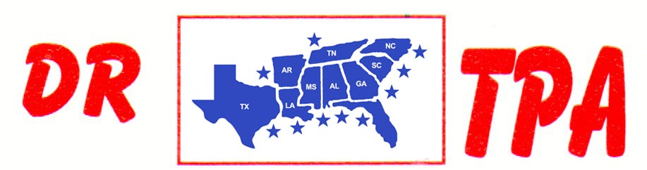

E4 FARMS
BROOKHAVEN, MS
MAY 24, 2025

SHOW RESULTS - #202523

OPEN HC TEAM PENNING – $810
1st PLACE CLAY EARLS – HANNA HALL – RON DUFOUR
2ND PLACE LAVONNE STRINGER – CLAY EARLS – PATRICK HALL

8 COW DRAW GROUP A - $630
1ST PLACE RON DUFOUR
2ND PLACE JONATHAN LOPINTO
3RD PLACE WALTER TEDESCO

8 COW DRAW GROUP B - $630
1ST PLACE HANNA HALL
2ND PLACE BECKY BROWN
3RD PLACE LAYTON EARLS

YOUTH SORT – $192
1st PLACE LAYTON EARLS – KATELYN WATKINS

