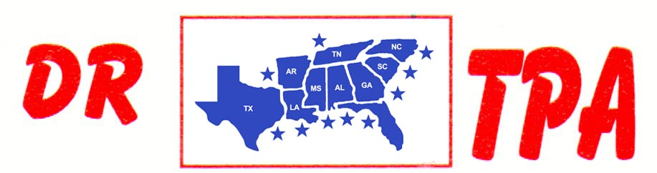

WA ARENA
SHERIDAN, AR
MAY 31 – JUNE 1, 2025

SHOW RESULTS - #202524

OPEN ALL DRAW RANCH SORTING - $1836
1ST PLACE DOUG VOLKMAN – PAUL CHILDRESS
2ND PLACE DAVID MCCOMAS – LYNDA MCCOMAS
3RD PLACE THOMAS DICKSON – MICHELLE CARNAHAN

#3 RANCH SORTING - $966
1ST PLACE SETH WHITLEY – SKIP DAVIDSON
2ND PLACE JORDAN WHITLEY – BROCK SPURLOCK

8 COW DRAW - $2520

GROUP A
1ST PLACE PAUL CHILDRESS 34 HEAD
2ND PLACE DOUG VOLKMAN 30 HEAD
3RD PLACE SKIP DAVIDSON 26 HEAD

GROUP B
1ST PLACE DARREN BAKER 31 HEAD
2ND PLACE JORDAN WHITLEY 21 HEAD
3RD PLACE DAVID MCCOMAS 21 HEAD

#9 PENNING - $729
1ST PLACE JOE FORNEY – MICHAEL MOSLEY – GARETT GATES

#7 PENNING - $1170
1ST PLACE DARREN BAKER – DOUG VOLKMAN – MICHAEL MOSLEY

#5 PENNING (2 CAP) - $345
1ST PLACE JESSICA DAVIS – SHANE FLEMING – MARK ALLEN

