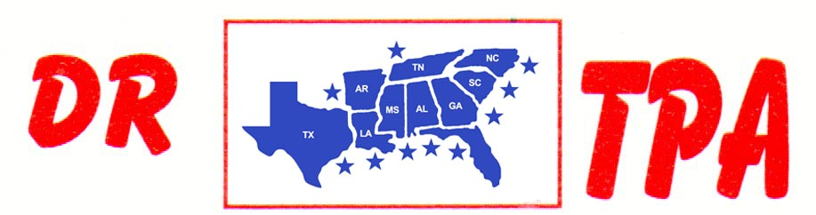

SOUTHERN RANCH SORTING
DUNNELLON, FL
JUNE 27-28, 2025

SHOW RESULTS - #202525

8 COW DRAW - $11,260 ($1500 ADDED MONEY)
1st PLACE MARCUS KENT 39 COWS
2ND PLACE JESUS MORA 36 COWS
3RD PLACE JORGE TAPIA 36 COWS
4TH PLACE KAI CLARK 34 COWS
5TH PLACE JOSEPH RICHARDS 33 COWS
6TH PLACE WILL FORTNER 33 COWS
7TH PLACE BAILEY SHELL 31 COWS
8TH PLACE GAVIN GOSIK 30 COWS

#6 PEN - $3759 ($250 ADDED MONEY)
1ST PLACE PEPPER KENT – ANGELA LAURAMORE – BAILEY SHELL
2ND PLACE MURAY KENT – CLAY COURSON – CHERYL KIRTON
3RD PLACE JONAS YODER – SANTIAGO ESPINOZA – PEPPER KENT
4TH PLACE RANDAL WEIDNER – HOLLY ANDERSON – SARAH FOTI
5TH PLACE JACK PARRA – TIFFANY HOLTZCLAW – OLIVIA CORVEDDU

#10 PEN $3354 ($250 ADDED MONEY)
1st PLACE SANTIAGO ESPINOZA – ANGELA LAURAMORE – SARAH FOTI
2ND PLACE JOSEPH RICHARDS – NICHOLAS KENT – CHAD DAY
3RD PLACE ROSS HARPER – BECKY DIXON – JESUS MORA
4TH PLACE DEBORAH OWENS – SERGIO BEVACQUA – SERGIO BEVACQUA, JR.

