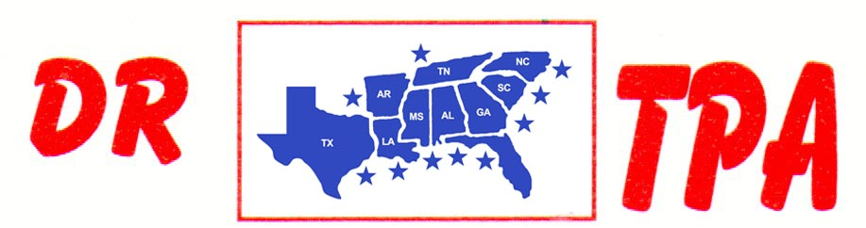

MARCUS KENT ARENA
DUNNELLON, FL
JULY 14-15, 2023

SHOW RESULTS - #202320

#6 SORT - $4898

1ST PLACE CLORALDO LEAL, JR. – EDUARDO LEAL
2ND PLACE BOB CORNETTE – FRANK PALMERO
3RD PLACE HANNAH DAMONE – ANNABETH GREEN
4TH PLACE BOB CORNETTE – BAILEY SHELL
5TH PLACE BOB SMITH – BRYAN EUBANKS
6TH PLACE JJ GONZALES – TIFFANY HOLTZCLAW

8 COW DRAW SORT - $6440

1ST PLACE BOB CORNETTE
2ND PLACE HANNAH DAMONE
3RD PLACE ANGELA LAURAMORE
4TH PLACE CLAY COURSON
5TH PLACE JONAS YODER
6TH PLACE SARAH FOTI
7TH PLACE SANTIAGO ESPINOZA

JR. YOUTH SORT

1ST PLACE CODY TYRE

