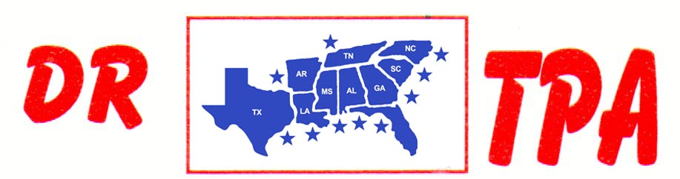

MARCUS KENT ARENA
DUNNELLON, FL
AUGUST 4-5, 2023

SHOW RESULTS - #202322

#6 SORT - $4130

1ST PLACE RYAN SCHERER – BOB CORNETTE
2ND PLACE BRENDA BROWN – CHAD DAY
3RD PLACE SALLY SHELL – PEPPER KENT
4TH PLACE CHAD DAY – BAILEY SHELL
5TH PLACE CAITLIN COCHRAN – RYAN SCHERER
6TH PLACE SARAH FOTI – BRYAN EUBANKS

8 COW DRAW SORT - $4620

1ST PLACE HANNAH DAMONE 45 COWS
2ND PLACE WALT PARNELL 38 COWS
3RD PLACE SALLY SHELL 37 COWS
4TH PLACE PEPPER KENT 36 COWS
5TH PLACE RYAN SCHERER 33 COWS
6TH PLACE WAYNE HOHL 33 COWS

JR. YOUTH SORT

1ST PLACE ASHLEY EUBANKS – HANNAH DAMONE
2ND PLACE ASHLEY EUBANKS – DYLAN
3RD PLACE CARTER SCHERER – JOSE SANCHEZ

