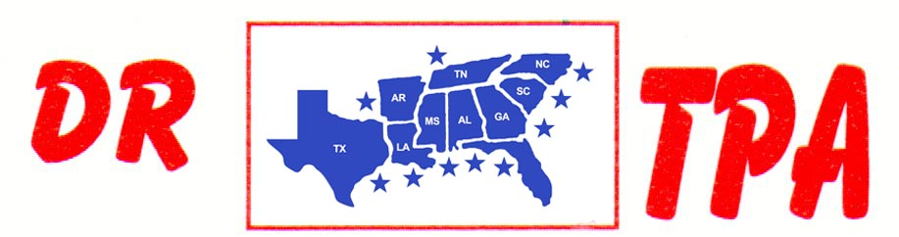

4K FARMS
YATESVILLE, GA
AUGUST 23, 2025

SHOW RESULTS - #202534

8 COW DRAW - $2720
1ST PLACE DANNY SODREL 31 COWS
2ND PLACE SCOTT KNIGHT 30 COWS
3RD PLACE AMY SODREL 29 COWS
4TH PLACE JOSEPH RICHARDS 28 COWS
5TH PLACE TRENT KNIGHT 28 COWS

#6 SHOOTOUT SORT - $2346
1ST PLACE RANDY MOORE – CHET BARRETT
2ND PLACE SCOTT KNIGHT – AMY SODREL
3RD PLACE RANDY MOORE – RANDAL WEIDNER
4TH PLACE GAGE MOORE – RANDY MOORE
5TH PLACE KAI CLARK – RANDAL WEIDNER

