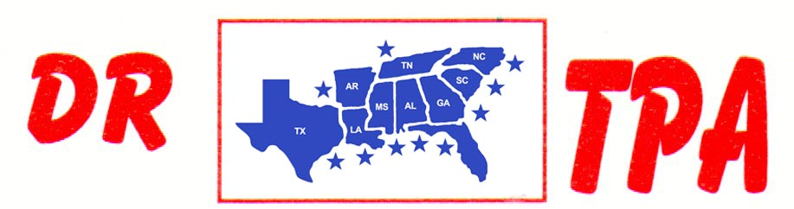

SA PRODUCTIONS, LLC
CLEMSON, SC
SEPTEMBER 12-14, 2025
SHOW RESULTS - #202537

#10 SHOOTOUT PEN - $3759 ($1000 ADDED MONEY)
1st PLACE DANNY SODREL – CARL KRAKER – CHET BARRETT
2ND PLACE ABIGAIL KNIGHT – SCOTT KNIGHT – TRENT KNIGHT
3RD PLACE CARL KRAKER – DANNY SODREL – IOSVANY CASTILLO
4TH PLACE DALE TENNANT – MEGAN TENNANT – DAY WATSON

#9 PEN - $1653 ($500 ADDED MONEY)
1ST PLACE TRENT KNIGHT – ABIGAIL KNIGHT – CHET BARRETT
2ND PLACE SCOTT KNIGHT – LAUREN REED – CHET BARRETT

#6 INCENTIVE PEN - $216
1ST PLACE JOSIE REED – LAUREN REED – HANNAH BAILEY

OPEN CHALLENGE SORT – $2040
1st PLACE TANNER KEITH – KAI CLARK
2ND PLACE TRENT KNIGHT – KAI CLARK

#8 SORT – $6144 ($2000 ADDED MONEY)
1st PLACE IOSVANY CASTILLO – DANNY SODREL
2nd PLACE CHET BARRETT – SCOTT KNIGHT
3RD PLACE AUBREE COKER – SCOTT KNIGHT
4TH PLACE CHET BARRETT – KAI CLARK
5TH PLACE AUBREE COKER – RANDY MOORE

#5 SORT – $3400
1st PLACE LARRY JORDAN – GARY LAPIERRE
2nd PLACE LARRY JORDAN – RANDY MOORE
3RD PLACE IOSVANY CASTILLO – JUSTIN JOHNSON
4TH PLACE JERRY SALTER – LIZ KING
5TH PLACE KIM HIERS – HALEY KNIGHT

#3 SORT – $2448
1ST PLACE JERRY SALTER – KIM HIERS
2ND PLACE JAXON HELMS – JEREMY LILES
3RD PLCE JEREMY REED – LAUREN REED
4TH PLACE CARLY ROBINSON – JIMMY CARSWELL
5TH PLACE JEREMY LILES – DAY WATSON

8 COW DRAW - $2080
1ST PLACE JP PEDRO 30 HEAD
2ND PLACE TANNER KEITH 22 HEAD
3RD PLACE DANNY SODREL 21 HEAD
4TH PLACE CAITLIN COCHRAN 20 HEAD
5TH PLACE KASEY COCHRAN 20 HEAD

SR. YOUTH SORT – $608
1ST PLACE ABIGAIL KNIGHT – MALI WHITAKER
2ND PLACE NEECEY NICHOLSON – SAVANNAH TEASLEY
3RD PLACE ADDY WYDOCK – ABIGAIL KNIGHT

JR. YOUTH SORT – $54
1ST PLACE NEECEY NICHOLSON – RANDY MOORE

