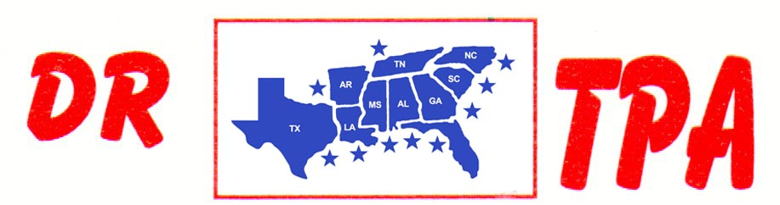

NO NAME ARENA
ALEXANDER, AR
SEPTEMBER 13, 2025
SHOW RESULTS - #202538

OPEN ALL DRAW RANCH SORTING - $2240
1ST PLACE SKIP DAVIDSON – MAY GUSTAFSON
2ND PLACE KENNETH ALTOM – DOUG VOLKMAN
3RD PLACE RANDY BARRETT – CHAD MITCHELL
4TH PLACE DOUG VOLKMAN – AMI ALTOM
5TH PLACE RANDY BARRETT – BROOKE MITCHELL

#8 RANCH SORTING - $2764
1ST PLACE DOUG VOLKMAN – AMI ALTOM
2ND PLACE BROOKE MITCHELL – DAVID MCCOMAS
3RD PLACE THOMAS DICKSON – WALLY HAYS
4TH PLACE BROOK MITCHELL – LAYNE PENFIELD
5TH PLACE KENNETH ALTOM – WALLY HAYS

#6 RANCH SORTING - $910
1ST PLACE JORDAN WHITLEY – DOUG VOLKMAN
2ND PLACE JASON HALEY – DAVID STANSBURY
3RD PLACE JORDAN WHITLEY – MARY HOBGOOD

