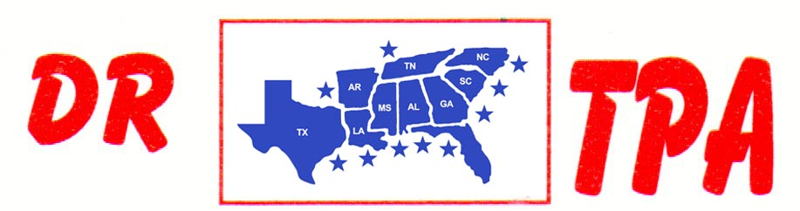

NO NAME ARENA
ALEXANDER, AR
OCTOBER 11, 2025
SHOW RESULTS - #202544

OPEN ALL DRAW RANCH SORTING - $1436
1ST PLACE SKIP DAVIDSON – LAYNE PENFIELD
2ND PLACE RANDY ENLOE – PATRICIA HALL
3RD PLACE LAYNE PENFIELD – AMI ALTOM
4TH PLACE PATRICIA HALL – KENNETH ALTOM

#8 RANCH SORTING - $1890
1ST PLACE LAYNE PENFIELD – WALLY HAYS
2ND PLACE SKIP DAVIDSON – DOUG VOLKMAN
3RD PLACE LAYNE PENFIELD – JERRY WHITLEY
4TH PLACE JESSICA DAVIS – RANDY ENLOE
5TH PLACE DICK TEAGUE – RANDY BARRETT

#6 RANCH SORTING - $456
1ST PLACE BRANDON KIKER – DOUG VOLKMAN

