
Team Penning & Sorting Horses, Training, Tack, Group & Individual Clinics Available
www.bucknercowhorses.com

Presents

Spring Fling

2 Shows in 1 Weekend

$10,000 Cash Money Added

CLIMATE CONTROLLED FACILITY
ARENA ONE
562 CUTTING HORSE LANE
BATESVILLE, MS 38606

$1000 Added

FRIDAY, APRIL 24, 2015 – 7:00 p.m.
Books close at 6:30 p.m. Sharp

# 11 Rated
3-MAN 2 GATE SORTING

USTPA Ratings

10 Ride limit – Pick up to 9 with 1 mandatory draw

$24 per ride 50% payback

Stalls: $40 night/$75 weekend (One Horse Per Stall/No Tie-Outs) –
ALL STALLS ARE PREBEDDED
RV Hookups $35 night
$10 Grounds Fee
FOR ADDITIONAL INFORMATION & to RESERVE STALLS & RV
CALL: Brian Buckner 601-867-1090
or EMAIL: brian@bucknercowhorses.com
****All info on this flyer is subject to change**

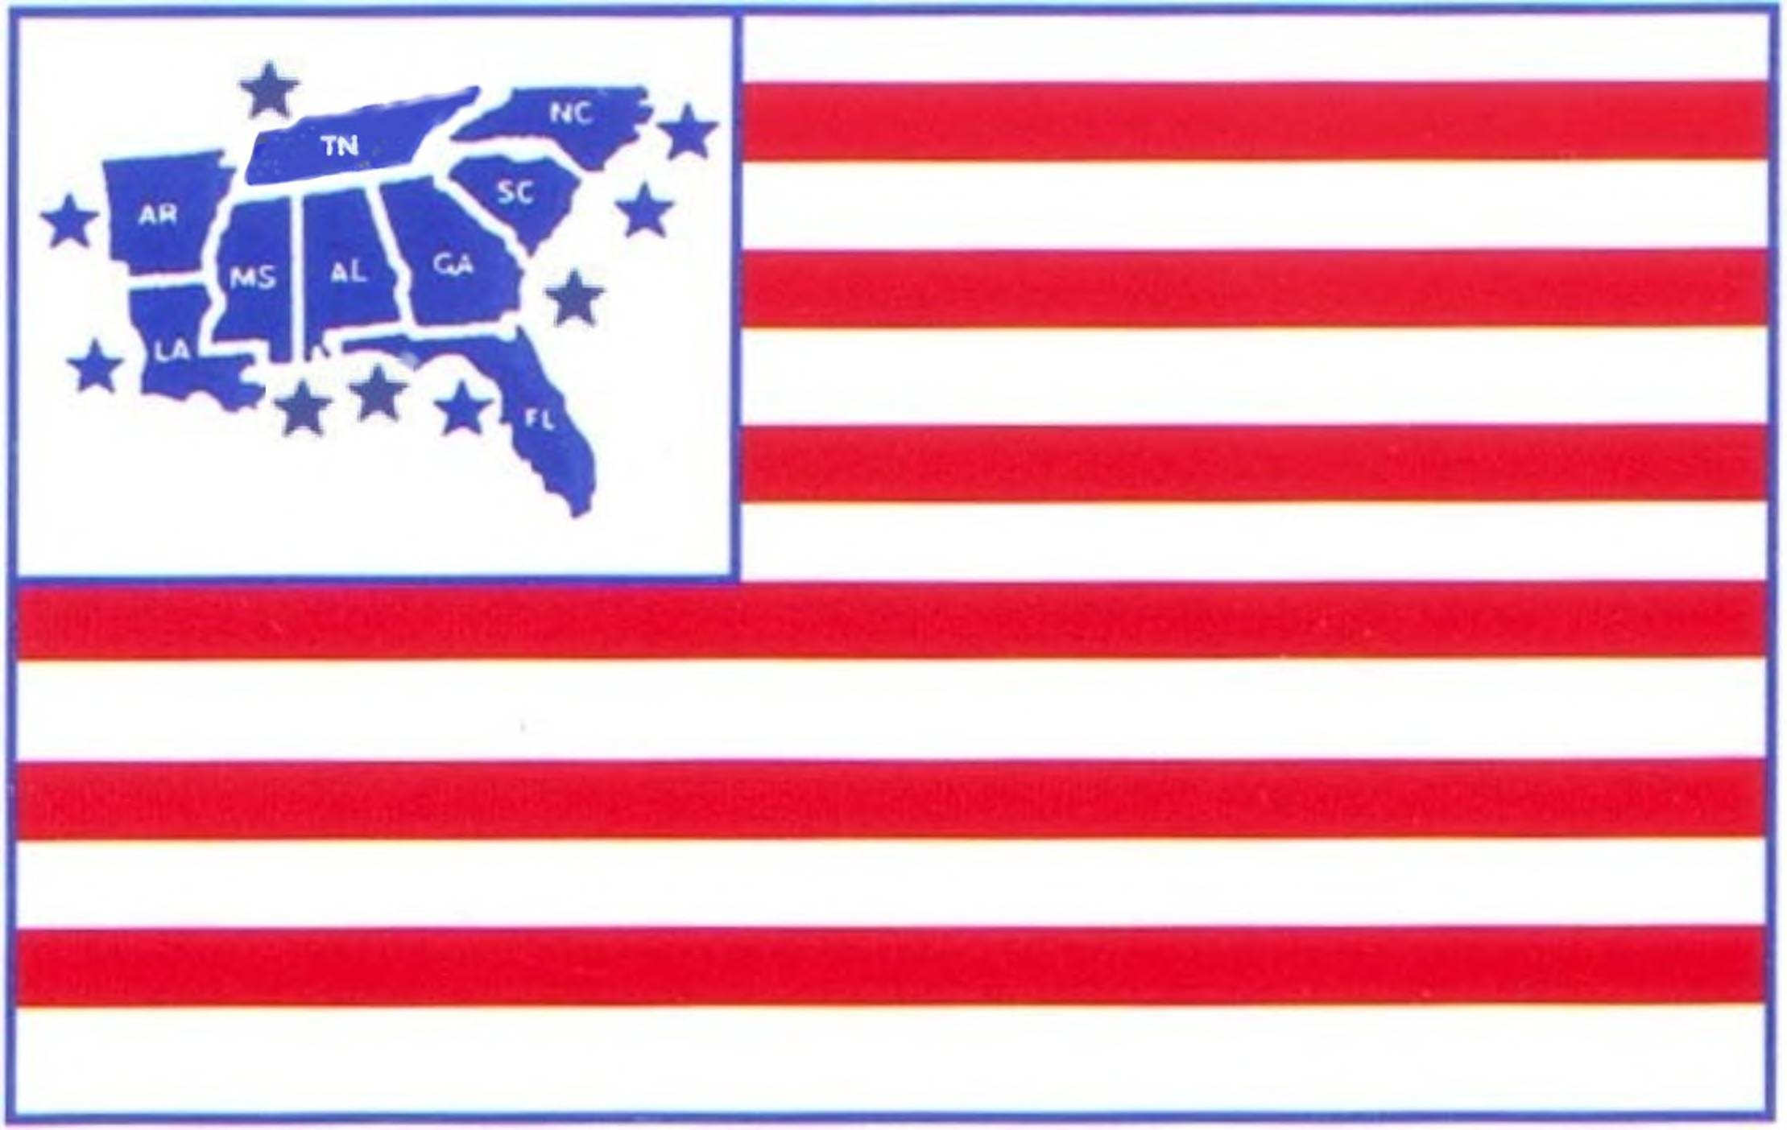DRTPA SANCTIONED SHOW - (RULES & RATINGS APPLY)
Co-Sanctioned – United States Team Penning Association

CLIMATE CONTROLLED FACILITY

ARENA ONE
562 CUTTING HORSE LANE
BATESVILLE, MS 38606

$5500 Added
SATURDAY, APRIL 25, 2015 - 9:00 a.m.
Books close at 8:30 a.m. Sharp

# 9 PENNING (PICK 4/DRAW 1 or DRAW UP TO 5) $50/rider 50% Payback $1000 Added ALL DRAW OPEN HANDICAP PENNING $50/rider 50% Payback $1000 Added
# 7 PENNING (PICK 4/DRAW 1 or DRAW UP TO 5) $50/rider 50% Payback $1000 Added
JR. YOUTH PENNING $12/rider $5 Payback/Rider
SR. YOUTH PENNING (PICK 1/DRAW 1 or DRAW UP TO 5) $15/rider 100% Payback
# 5 PENNING (PICK 1/DRAW 1 or DRAW UP TO 5) $50/rider 50% Payback $1000 Added
ALL DRAW - OPEN HANDICAP RANCH SORTING $50/rider 60% Payback $750 Added
# 6 RANCH SORTING (PICK 4/DRAW 1 or DRAW UP TO 5) $50/rider 60% Payback $750 Added

Must be a member of DRTPA to participate - Memberships available at show - Individual $30/Family $40/Day Permit $10 (will be rated as a # 5 rider ~ ~ ~ 40% FOUL LINE/NO TRASH/FIVE RIDE LIMIT ~ ~ ~ Top 30% to 2nd Go & Top 10 to Finals (Progressive) ! ! ! $6 Association & Arena Fees Included in all entry fees.

Stalls: $40 night/$75 weekend (One Horse Per Stall/No Tie-Outs) –
ALL STALLS ARE PREBEDDED
RV Hookups $35 night
$10 Grounds Fee
FOR ADDITIONAL INFORMATION & to RESERVE STALLS & RV
CALL: Brian Buckner 601-867-1090
or EMAIL: brian@bucknercowhorses.com
****All info on this flyer is subject to change****

Team Penning & Sorting Horses, Training, Tack, Group & Individual Clinics Available
www.bucknercowhorses.com

Presents
Spring Fling

USTPA SANCTIONED SHOW - (RULES & RATINGS APPLY)
MUST BE MEMBER OF USTPA TO PARTICIPATE

CLIMATE CONTROLLED FACILITY

ARENA ONE
562 CUTTING HORSE LANE
BATESVILLE, MS 38606

$3500 Added
SUNDAY, APRIL 26, 2015 - 8:00 a.m.
Books close at 7:30 a.m. Sharp

ALL DRAW OPEN PENNING $50/rider 50% Payback $1000 Added
# 11 PENNING (Pick 3/Draw 1 or Draw up to 4) $50rider 50% Payback $1000 Added
JR. YOUTH PENNING $15/rider 100% Payback
SR. YOUTH PENNING $15/rider 75% Payback
ALL DRAW OPEN RANCH SORTING $50/rider 60% Payback $750 Added
# 3 RANCH SORTING (Pick 3/Draw 1 or Draw up to 4) $50/rider 60% Payback $750 Added
JR. YOUTH RANCH SORTING $15/rider 100% Payback
SR. YOUTH RANCH SORTING $15/rider 80% Payback

Stalls: $40 night/$75 weekend (One Horse Per Stall/No Tie-Outs) –
ALL STALLS ARE PRBEDDED
RV Hookups $35 night
$10 Grounds Fee
FOR ADDITIONAL INFORMATION & to RESERVE STALLS & RV
CALL: Brian Buckner 601-867-1090
or EMAIL: brian@bucknercowhorses.com
****All info on this flyer is subject to change****

