
Team Penning & Sorting Horses, Training, Tack, Group & Individual Clinics Available
www.bucknercowhorses.com

3 Shows in 1 Weekend

CLIMATE CONTROLLED FACILITY
ARENA ONE
562 CUTTING HORSE LANE
BATESVILLE, MS 38606


$ 500 ADDED
FRIDAY, APRIL 25, 2014 – 7:00 p.m.

3-D Southeastern 3-D Series

No Ratings

3-MAN 2 GATE SORTING
10 Ride limit – Pick up to 9 with 1 mandatory draw

$24 per ride 50% payback

Stalls: $40 night/$75 weekend (One Horse Per Stall/No Tie-Outs) –
ALL STALLS ARE PREBEDDED
RV Hookups $35 night
$10 Grounds Fee
FOR ADDITIONAL INFORMATION & to RESERVE STALLS & RV
CALL: Brian Buckner 601-867-1090
or EMAIL: brian@bucknercowhorses.com
****All info on this flyer is subject to change**

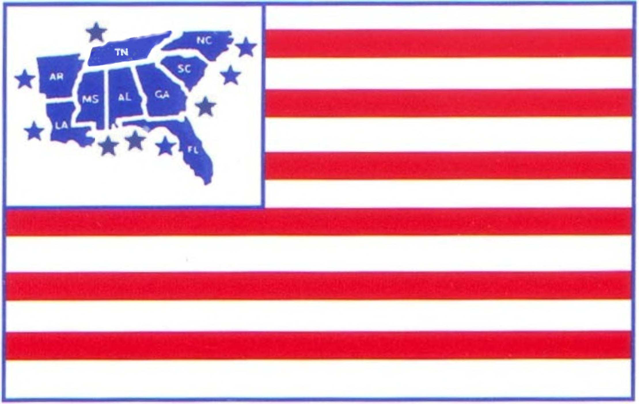DRTPA SANCTIONED SHOW - (RULES & RATINGS APPLY)
Co-Sanctioned – United States Team Penning Association

CLIMATE CONTROLLED FACILITY

ARENA ONE
562 CUTTING HORSE LANE
BATESVILLE, MS 38606

$1500 ADDED

SATURDAY, APRIL 26, 2014 - 9:00 a.m.
BOOKS CLOSE AT 8:30 a. m.

# 9 PENNING (PICK 4/DRAW 1 or DRAW UP TO 5) $45/rider 50% Payback $500 Added ALL DRAW OPEN HANDICAP PENNING $35/rider 50% Payback
# 11 MIXED PENNING (PICK 4/DRAW 1 or DRAW UP TO 5) $35/rider 50% Payback
# 7 PENNING (PICK 4/DRAW 1 or DRAW UP TO 5) $40/rider 50% Payback $500 Added
JR. YOUTH PENNING $12/rider $5 Payback/Rider
SR. YOUTH PENNING (PICK 1/DRAW 1 or DRAW UP TO 5) $15/rider 100% Payback
# 5 PENNING (PICK 1/DRAW 1 or DRAW UP TO 5) $35/rider 50% Payback
ALL DRAW - OPEN HANDICAP RANCH SORTING $35/rider 60% Payback
# 6 RANCH SORTING (PICK 4/DRAW 1 or DRAW UP TO 5) $40/rider 60% Payback $500 Added

Must be a member of DRTPA to participate - Memberships available at show - Individual $30/Family $40/Day Permit $10 (will be rated as a # 5 rider ~ ~ ~ 40% FOUL LINE/NO TRASH/FIVE RIDE LIMIT ~ ~ ~ Top 30% to 2nd Go & Top 10 to Finals (Progressive) ! ! ! $6 Association & Arena Fees Included in all entry fees.

Stalls: $40 night/$75 weekend (One Horse Per Stall/No Tie-Outs) –
ALL STALLS ARE PREBEDDED
RV Hookups $35 night
$10 Grounds Fee
FOR ADDITIONAL INFORMATION & to RESERVE STALLS & RV
CALL: Brian Buckner 601-867-1090
or EMAIL: brian@bucknercowhorses.com
****All info on this flyer is subject to change****

USTPA SANCTIONED SHOW - (RULES & RATINGS APPLY)
MUST BE MEMBER OF USTPA TO PARTICIPATE

CLIMATE CONTROLLED FACILITY

ARENA ONE
562 CUTTING HORSE LANE
BATESVILLE, MS 38606

$500 ADDED

SUNDAY, APRIL 27, 2014 - 8:00 a.m.

ALL DRAW OPEN PENNING $40/rider 50% Payback
# 11 PENNING (Pick 3/Draw 1 or Draw up to 4) $45/rider 50% Payback $500 ADDED
# 3 ALL DRAW $40/rider 50% Payback
JR. YOUTH PENNING $15/rider 100% Payback
SR. YOUTH PENNING $15/rider 75% Payback
ALL DRAW OPEN RANCH SORTING $40/rider 60% Payback
# 3 RANCH SORTING (Pick 3/Draw 1 or Draw up to 4) $40/rider 60% Payback
JR. YOUTH RANCH SORTING $15/rider 100% Payback
SR. YOUTH RANCH SORTING $15/rider 80% Payback

Stalls: $40 night/$75 weekend (One Horse Per Stall/No Tie-Outs) –
ALL STALLS ARE PRBEDDED
RV Hookups $35 night
$10 Grounds Fee
FOR ADDITIONAL INFORMATION & to RESERVE STALLS & RV
CALL: Brian Buckner 601-867-1090
or EMAIL: brian@bucknercowhorses.com
****All info on this flyer is subject to change****

