DIXIE REGIONAL TEAM PENNING ASSOCIATION

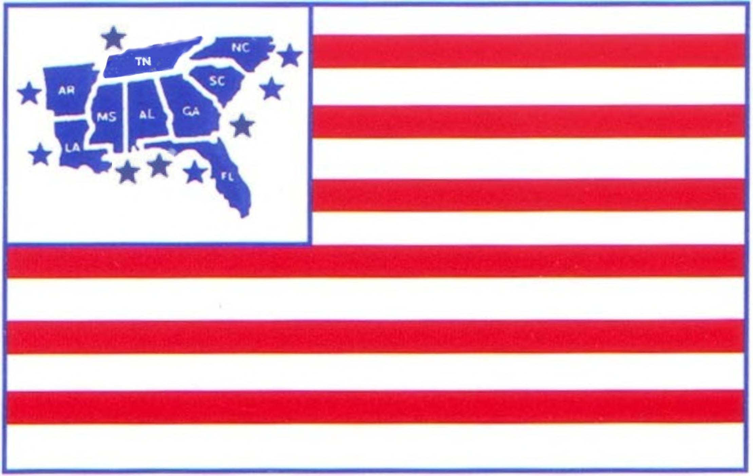 Waynesboro, GA
BSC Arena

August 20, 2016
To follow RSNC

DRTPA SANCTIONED EVENT

Covered
Arena

Sorting
DRTPA not to start before 3pm
DRTPA membership required and available at show. Individual $30/Family $40/Day Permit $10 ~ 40% foul line/no trash/5 ride limit 1 mandatory draw or draw up to five. Top 30% to 2nd go & Top 10 to Finals (progressive). Fewer than 25 teams will be 1st go and top 10 only.
$5 Association and Arena fee included in each entry fee.

Youth Ranch Sorting $15/ride 50% payback

All Draw Open Handicap Penning - $25.00/ride 50% payback

#9 Penning - $25/ride 50% payback

Location:  BSC Covered Arena  Stalls/$10 and RV hookups/$15 per night.  Please Reserve | Directions:  3976 Hwy 24 south  Waynesboro Ga  Host Hotel : Hampton Inn  706-558-4190
Contact Johnny Lovett at #706-551-2190 or Cliff Chancey at #706-840-3971 with any questions
*** All info on this flyer is subject to change. ***

