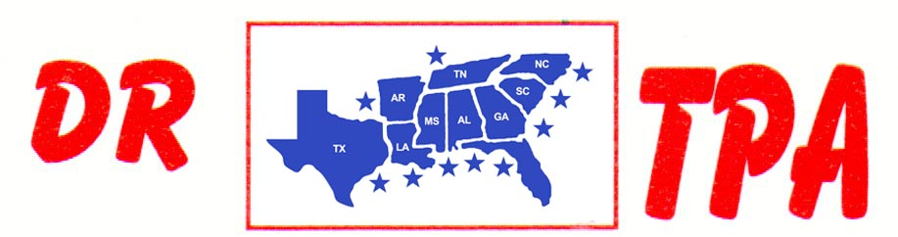
P. O. BOX 203 * Waring, TX 78074
Phone & Fax: 409-656-1196
E-MAIL: drtpa@outlook.com WEBSITE: drtpa.com
2023 NEW/RENEWAL MEMBERSHIP APPLICATION

PLEASE PRINT CLEARLY MEMBERSHIP NUMBER: ______________ RENEWAL RATING: __________

NAME: _____________________________________________________________________ SOCIAL SECURITY NO. _______________________________

ADDRESS: _______________________________________________________________________________________ DATE OF BIRTH: _______________

CITY: ____________________________________________________________________ STATE: ________________ ZIP CODE: ___________________

TELEPHONE NO.: ________________________________________________________________________ ( ) Cell ( ) Home

E-MAIL: ____________________________________________________________________________________________________________________________
_______________________________________________________________________________________________________________________________________

New Members only fill out this section :

PLEASE LIST ANY TEAM PENNING OR SORTING ASSOCIATION IN WHICH YOU ARE A MEMBER ALONG WITH YOUR RATING IN THAT ASSOCIATION:

1. _________________________________ RATING: _________ 2. _______________________________ RATING: ________

3. _________________________________ RATING: _________ 4. _______________________________ RATING: ________

MONEY WON AT ALL TEAM PENNINGS & SORTINGS – 01/01/2022 to 12/31/2022
CIRCLE ONE
$ -0- to $500 $501 to $2,000 $2,001 to $3,500
$3,501 to $5,000 $5,001 to $7,500 $7,501 to $10,000
$10,001 to $15,000 $15,001 to $20,000 over $20,000
________________________________________________________________________________________________________________

THE YEARLY MEMBERSHIP DUES ARE $30.00 FOR AN INDIVIDUAL AND $40.00 FOR A FAMILY. FAMILY IS DEFINED AS HUSBAND, WIFE, AND ANY CHILDREN UNDER THE AGE OF 18 LIVING AT HOME. RETURN THIS COMPLETED FORM AND MEMBERSHIP DUES TO: DRTPA – P. O. BOX 203 – WARING, TX 78074.

PARTICIPATION IN DRTPA EVENTS – TERMS AND CONDITIONS:

I hereby covenant not to sue and agree to indemnity, and save and hold harmless “DIXIE REGION TEAM PENNING ASSOCIATION”, its agents, employees, representatives, producers, and all others in any way connected with the production and operation of the event, and the facilities from any claim, demand, or liability for personal injuries or property damage arising from participation or use and enjoyment of the event and facilities. Further, my consent is given for my membership information to be given to fellow DRTPA membership. This consent will remain in effect for a period of one (1) year. The undersigned has read and voluntarily signed the covenant and indemnity agreement, and further agrees that no oral representation, statement of inducements apart from the foregoing agreements have been made.

SIGNED: _______________________________________________________ DATED: ___________________________________
NOTE: This consent/release must be signed by a parent or guardian for all membership/contestants who are minors.

